Create mirror server ubuntu
1. Primary database

- create service
/opt/sqlanywhere17/bin64s/dbsvc -a root -t network -s automatic -w OrlansoftSvc -x"tcpip(PORT=49152;dobroadcast=no)" -n Server1 -o /opt/Database/primary/servermsg.txt /opt/Database/primary/Orlansoft.db -n Orlansoft -xp on

- Start service database primary
sudo /opt/sqlanywhere17/bin64s/dbsvc -u OrlansoftSvc

- cek status service database
systemctl status SA_OrlansoftSvc
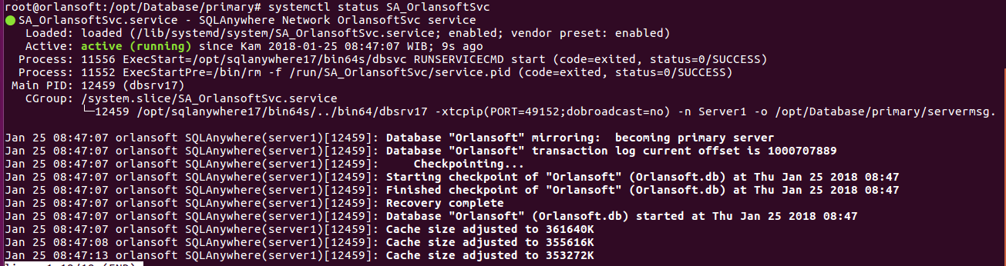
- konek ke interactive sql database primary
// Mendefiniskan dua partner server di sistem mirroring
CREATE MIRROR SERVER Server1
AS PARTNER
connection_string='SERVER=Server1;host=192.168.0.25:49152'
state_file='/opt/Database/primary/Server1.state';

CREATE MIRROR SERVER Server2
AS PARTNER
connection_string='SERVER=Server2;host=192.168.0.25:49153'
state_file='/opt/Database/secondary/Server2.state';

// Mendefiniskan primary server untuk alias di sistem mirroring
CREATE MIRROR SERVER PrimaryServer
AS PRIMARY
connection_string='SERVER=PrimaryServer;HOST=192.168.0.25:49152,192.168.0.25:49153';

// Mendefiniskan arbiter server di sistem mirroring

CREATE MIRROR SERVER ArbiterServer
AS ARBITER
connection_string ='SERVER=ArbiterServer;HOST=192.168.0.25:2638';

// Mendefiniskan authentication untuk sistem mirroring

SET MIRROR OPTION authentication_string='abc';

// Backup database untuk dijalankan sebagai server 2

BACKUP DATABASE DIRECTORY '/opt/Database/secondary/';

2. Secondary Database

- Create service database secondary
/opt/sqlanywhere17/bin64s/dbsvc -a root -t network -s automatic -w OrlansoftSvcSecondary -x"tcpip(PORT=49153;dobroadcast=no)" -su passwd -n Server2 -o /opt/Database/secondary/servermsg.txt /opt/Database/secondary/Orlansoft.db -n Orlansoft -xp on

- Start service database secondary
sudo /opt/sqlanywhere17/bin64s/dbsvc -u OrlansoftSvcSecondary

- cek status service database
systemctl status SA_OrlansoftSvcSecondary

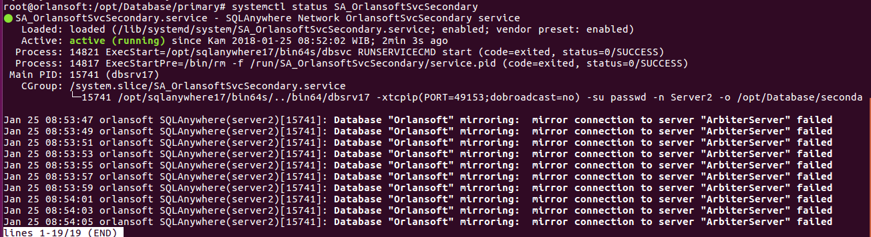

3. Arbiter

- Create service arbiter
/opt/sqlanywhere17/bin64s/dbsvc -a root -t network -s automatic -w OrlansoftSvcArbiter -x"tcpip(PORT=2638)" -n ArbiterServer -xa "auth=abc;dbn=Orlansoft" -o /opt/Database/arbiter/servermsg.txt -xf /opt/Database/arbiter/arbiterstate.txt

- Start service arbiter
sudo /opt/sqlanywhere17/bin64s/dbsvc -u OrlansoftSvcArbiter

- cek status service arbiter
systemctl status SA_OrlansoftSvcArbiter
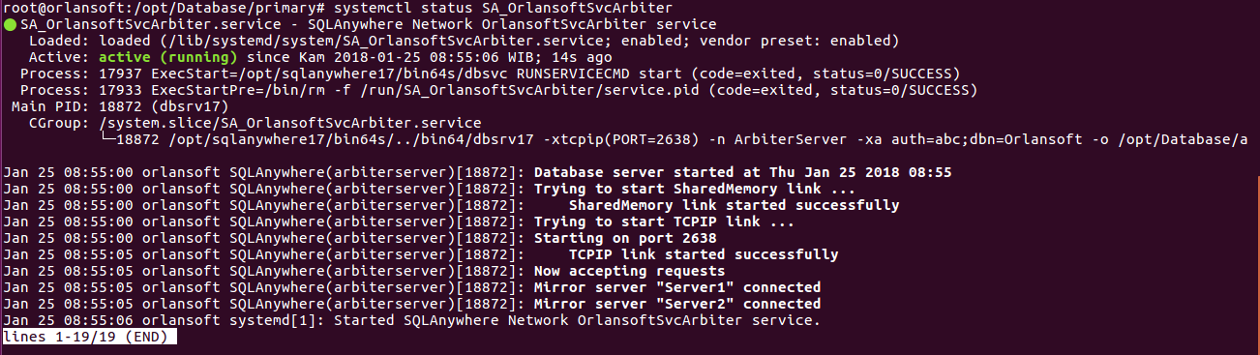
4. Scale Out

- Setting scale -out di isql server1
// Mendefiniskan mirror server dari sistem mirroring

CREATE MIRROR SERVER MirrorServer
AS MIRROR
connection_string='SERVER=MirrorServer;HOST=192.168.0.25:49154';

// Backup database untuk dijalankan sebagai child node dari sistem mirroring

BACKUP DATABASE DIRECTORY '/opt/Database/scaleout';

- Create service scale out
/opt/sqlanywhere17/bin64s/dbsvc -a root -t network -s automatic -w OrlansoftSvcMirror -x"tcpip(PORT=49154;dobroadcast=no)" -su passwd -n Mirror -o /opt/Database/scaleout/servermsg.txt /opt/Database/scaleout/Orlansoft.db -n Orlansoft -xp on

- Start service scaleout
sudo /opt/sqlanywhere17/bin64s/dbsvc -u OrlansoftSvcMirror

- cek status service scaleout
systemctl status SA_OrlansoftSvcMirror
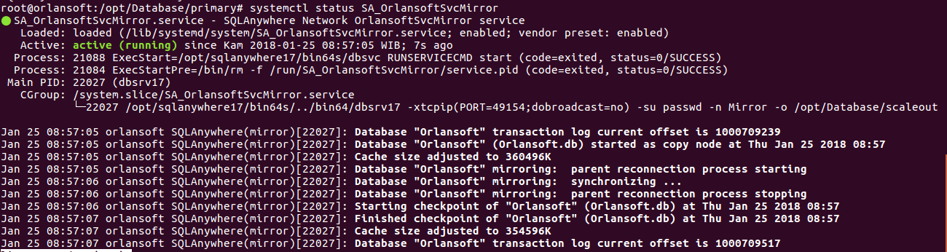

- Cek pada sybase
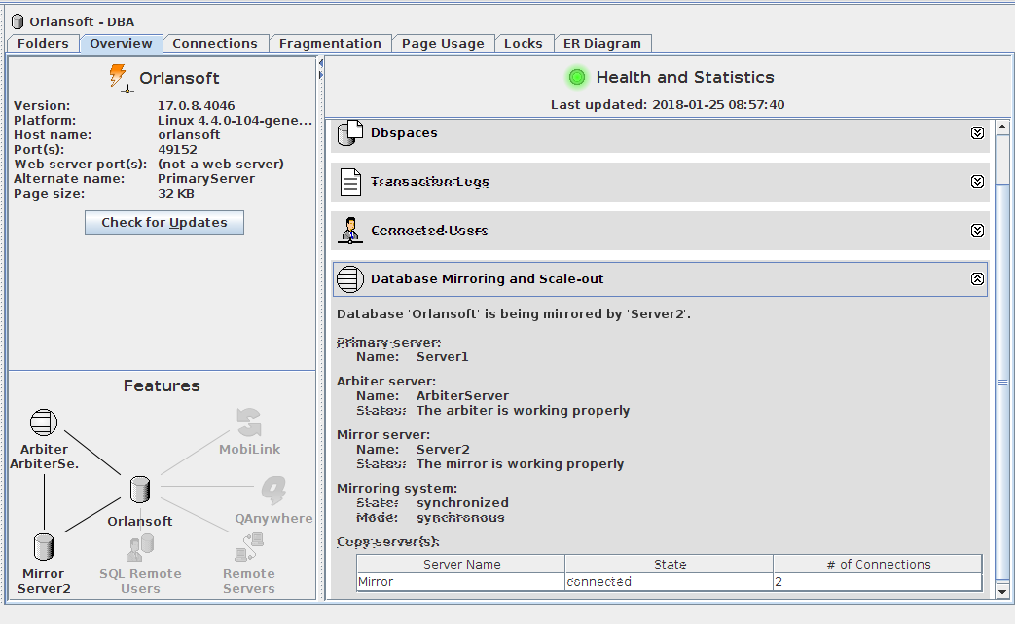

Create Mirror Server Windows

dbsvc -as -i -t network -s automatic -w ARBITER_SVC "C:\Program Files\SQL Anywhere 17\Bin64\dbsrv17" -xtcpip(PORT=2638) -n ARBITER_SRV -xa "auth=abc;dbn=DRI" -o C:\source\DATABASE\DB\DBLive\arbitermsg.txt -xf C:\source\DATABASE\DB\DBLive\arbiterstate.txt

dbsvc -as -i -t network -s automatic -w SERVER1_SVC "C:\Program Files\SQL Anywhere 17\Bin64\dbsrv17" -c2g -ch14g -xtcpip(PORT=2638;dobroadcast=no) -n SERVER1_SRV -o "C:\source\DATABASE\DB\DBLive\servermsg.txt" "C:\source\DATABASE\DB\DBLive\Orlansoft.db" -n DRI -xp on

dbsvc -as -i -t network -s automatic -w SERVER2_SVC "C:\Program Files\SQL Anywhere 17\Bin64\dbsrv17" -c2g -ch14g -xtcpip(PORT=2638;dobroadcast=no) -n SERVER2_SRV -o "C:\source\DATABASE\DB\DBLive\servermsg.txt" "C:\source\DATABASE\DB\DBLive\Orlansoft.db" -n DRI -xp on

select * from sysmirrorserver

// Mendefiniskan dua partner server di sistem mirroring

CREATE OR REPLACE MIRROR SERVER SERVER1_SRV
AS PARTNER
connection_string='SERVER=SERVER1_SRV;host=10.100.4.74:2638'
state_file='C:\source\DATABASE\DB\DBLive\serverstate.txt'
preferred='YES';

CREATE OR REPLACE MIRROR SERVER SERVER2_SRV
AS PARTNER
connection_string='SERVER=SERVER2_SRV;host=10.100.4.79:2638'
state_file='C:\source\DATABASE\DB\DBLive\serverstate.txt'
preferred='NO';

// Mendefiniskan primary server untuk alias di sistem mirroring

CREATE OR REPLACE MIRROR SERVER PRIMARY_SRV
AS PRIMARY
connection_string='SERVER=PRIMARY_SRV;HOST=10.100.4.74:2638,10.100.4.79:2638';

// Mendefiniskan arbiter server di sistem mirroring

CREATE OR REPLACE MIRROR SERVER ARBITER_SRV
AS ARBITER
connection_string ='SERVER=ARBITER_SRV;HOST=10.100.4.75:2638';

// Mendefiniskan authentication untuk sistem mirroring

SET MIRROR OPTION authentication_string='abc';

